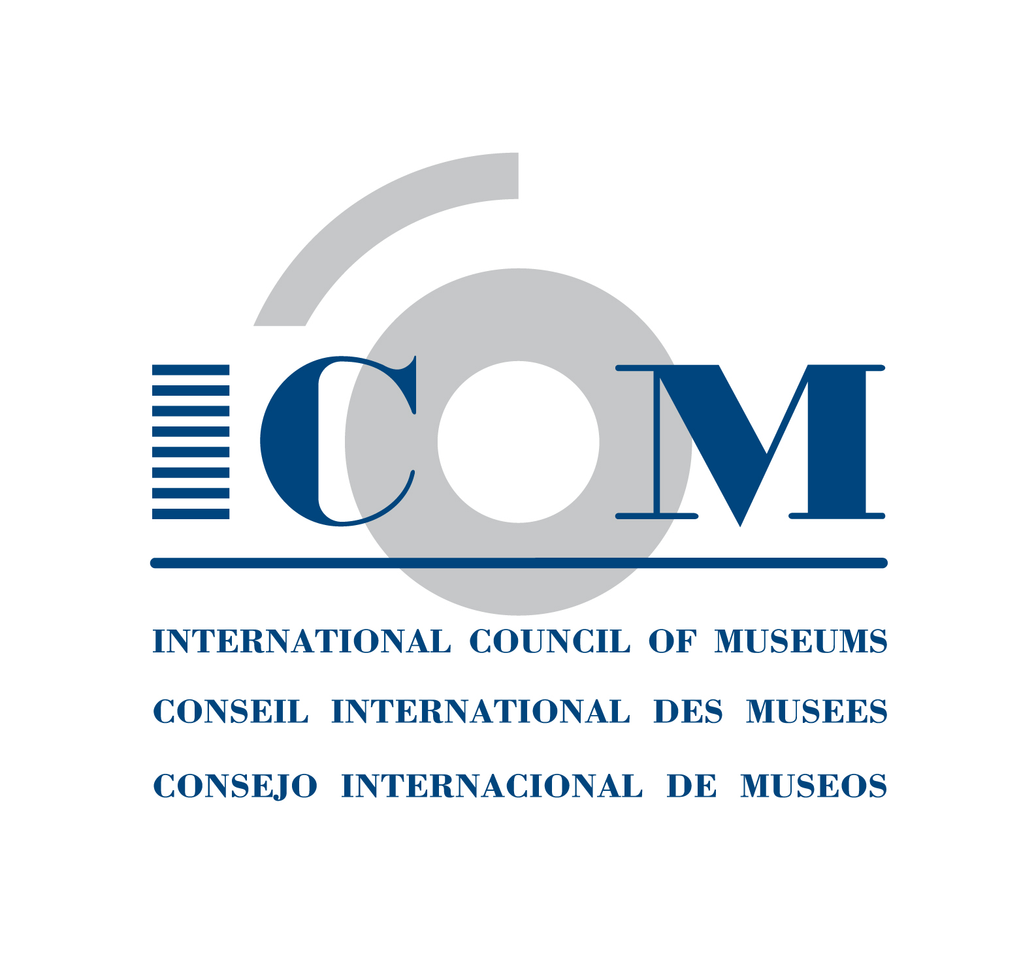  Tel. + 33 (0) 1 47 34 05 00  Fax + 33 (0) 1 43 06 78 62  Email: secretariat@icom.museum  http://icom.museum | INSTITUTIONAL MEMBERSHIP  APPLICATION FORM  Countries with a National Committee  This form is to be completed (PLEASE WRITE LEGIBLY) and  returned to your National Committee

Name of institution in English (required):

Name of institution in your language (optional):

Date of establishment:

Mailing address:

City: | Postal code: |  | Country:
Tel.:  (Please indicate country & area code) |  | Fax:
Email:

Institution’s Web Site:

Name of your museum/institution’s Director:

Name and position of person to whom correspondence should be addressed:

Category of membership:

- Regular I (voting) = operating budget* < €30.000
- Regular II (voting) = operating budget* from €30.000 to €100 000
- Regular III (voting) = operating budget* from €100.000 to €1.000.000
- Regular IV (voting) = operating budget* from €1.000.000 to €10.000.000
- Regular V (voting) = operating budget* > €10.000.000
- Sustaining (voting)
- Contributing (voting)
- Supporting (non-voting)

* The operating budget concerns the whole expenses of the institution, excepting capital expenditures.

PLEASE NOTE: Membership is annual and runs from January 1 to December 31 of the year in which subscriptions are paid. New memberships received after September 30 will become effective as from January 1 of the following year unless otherwise indicated.

Language for correspondence: (tick one) □English □French

Language for publications: (tick one) □English □French □Spanish

Please tick the categories which apply to your institution:

A. CATEGORY OF INSTITUTION:
❑ Botanical Garden | ❑ Museum
❑ Conservation Institute | ❑ Natural Park/Animal Reserve
❑ Cultural Centre | ❑ Research/Training Institute
❑ Exhibition Gallery | ❑ Zoological Garden/Aquarium
❑ Library/Archives | OTHER (please specify):

B. GOVERNING STATUS:
❑ Association | ❑ Private
❑ County | ❑ Provincial
❑ Foundation/Society | ❑ Regional
❑ Municipal   National | ❑ University  OTHER (please specify):

C. TYPE OF COLLECTION:
❑ Agriculture/Rural Heritage | ❑ Maritime
❑ Applied Arts | ❑ Medicine
❑ Archaeology | ❑ Military History
❑ Architecture | ❑ Modern & Contemporary Art
❑ Children's Museum | ❑ Money & Banking
❑ Costume | ❑ Musical Instruments
❑ Decorative Arts / Design | ❑ Natural History
❑ Eco museum | ❑ Open-air
❑ Education | ❑ Performing Arts
❑ Ethnology/Ethnography | ❑ Photography
❑ Fine Arts | ❑ Regional/Local
❑ Historic House | ❑ Science & Technology
❑ History | ❑ Sculpture
❑ Industrial Heritage | ❑ Sports
❑ Literature | ❑ Transport & Communications
OTHER : (please specify)

Note: The above information will be automatically processed to ensure your receipt of services from ICOM and will also be transmitted to third parties (i.e. International Committees). In conformity with the French law on Informatics & Civil Liberties (Jan. 6, 1978, rev.) you have the right of access and to modify the information that concerns you.
****************************************************************************
Please complete, date and sign the following declaration:

I,_______________________________, declare that my institution is eligible for membership
of the International Council of Museums (ICOM) and wishes to become a member of ICOM.
My institution does not engage in dealing (i.e. buying and selling for profit) in the field of cultural property and accepts the ICOM Code of Ethics for Museums.

DATE:___________________ SIGNATURE:___________________________________
November 2009

